HADOOP LAB MANUAL
CSC304L - Parallel and Distributed Computing Lab
Week 2: Hadoop Architecture and Ecosystem
University: | UET Lahore
Course Code: | CSC304L
Duration: | 3 Hours

Lab Objectives
By the end of this lab, you will:
- Understand the core components of Hadoop architecture
- Explore HDFS (Hadoop Distributed File System) in detail
- Understand the MapReduce programming model
- Work with HDFS commands and operations
- Write and execute MapReduce programs in Python
- Analyze MapReduce job execution and performance

Mapped Course Learning Outcome
CLO1: Demonstrate understanding of basic principles and programming models used in parallel and distributed computing.

THEORY

1. Hadoop Architecture - Core Components
Hadoop is built on a master-slave architecture with the following core components:

A. HDFS Layer (Storage)
- NameNode (Master): Manages the file system namespace, stores metadata (file names, permissions, locations of blocks). Runs on a single master machine.
- DataNode (Slave): Stores actual data blocks. Multiple DataNodes run on slave machines. Sends heartbeats to NameNode every 3 seconds.
- Secondary NameNode: NOT a backup! Performs periodic checkpointing of NameNode metadata to prevent it from growing too large.

B. YARN Layer (Resource Management)
- ResourceManager (Master): Manages cluster resources, schedules jobs, allocates resources to applications.
- NodeManager (Slave): Runs on each slave node, manages containers, monitors resource usage (CPU, memory, disk).
- ApplicationMaster: Per-application master that negotiates resources and works with NodeManager to execute tasks.

C. MapReduce Layer (Processing)
- Job Tracker: (In Hadoop 1.x) Manages MapReduce jobs. In Hadoop 2.x+, this is replaced by YARN.
- Task Tracker: (In Hadoop 1.x) Executes individual tasks. In Hadoop 2.x+, NodeManager handles this.

2. HDFS (Hadoop Distributed File System)

A. HDFS Architecture
HDFS is designed to store very large files across multiple machines:
- Block-based Storage: Files are split into blocks (default 128MB in Hadoop 2.x+, 64MB in Hadoop 1.x)
- Replication: Each block is replicated 3 times (default) across different nodes for fault tolerance
- Write Once, Read Many: Files cannot be modified after writing (only append supported)
- Data Locality: Processing moves to data, not data to processing

B. HDFS Read Operation
- Client asks NameNode for file location
- NameNode returns list of DataNodes with blocks
- Client reads blocks directly from DataNodes
- Client assembles blocks into complete file

C. HDFS Write Operation
- Client requests NameNode to create file
- NameNode checks permissions and availability
- Client writes first block to nearest DataNode
- DataNode replicates block to other DataNodes (pipeline)
- Process repeats for all blocks
- NameNode updates metadata after successful write

3. MapReduce Programming Model
MapReduce is a programming model for processing large datasets in parallel:

A. MapReduce Phases
- Input Split: Input data is divided into fixed-size splits (usually one block = one split)
- Map Phase: Each mapper processes one split and produces key-value pairs
- Shuffle & Sort: Framework groups all values for same key together and sorts by key
- Reduce Phase: Each reducer processes one key and all its values
- Output: Final results written to HDFS

B. MapReduce Example: Word Count
Input: "hello world hello hadoop"
Map Output (key-value pairs):
(hello, 1) (world, 1) (hello, 1) (hadoop, 1)
After Shuffle & Sort:
(hadoop, [1]) (hello, [1, 1]) (world, [1])
Reduce Output:
(hadoop, 1) (hello, 2) (world, 1)

C. MapReduce Execution Flow
Step | Description
Input | Data stored in HDFS, divided into blocks
Splitting | Input divided into splits (usually 1 block = 1 split)
Mapping | Mapper processes each split in parallel, outputs (key, value) pairs
Shuffling | All values for same key grouped together across all mappers
Sorting | Keys sorted before sending to reducer
Reducing | Reducer processes each key and all its values, outputs final result
Output | Final results written to HDFS

PRACTICAL EXERCISES
⚠️ PREREQUISITE: Make sure your Hadoop VM from Week 1 is running!

Start Hadoop Services
Open Terminal (Ctrl+Alt+T) and type:
start-dfs.sh
💡 What this does: Starts HDFS services (NameNode and DataNode)
Verify services are running:
jps
💡 What this does: Shows all Java processes running. You should see NameNode and DataNode.
✅ Expected Output: You should see at least:
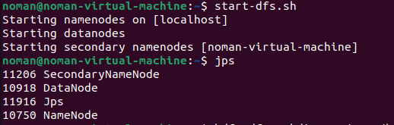
If you don't see these, Hadoop is not running properly. Ask your instructor for help.

Exercise 1: HDFS File Operations

Command 1: Create Directories in HDFS
Type this command:
hdfs dfs -mkdir -p /user/hadoop/week2/input
💡 Command Breakdown:
- hdfs dfs: Tells Hadoop to run a file system command
- -mkdir: Make directory (like creating a folder)
- -p: Create parent directories if they don't exist
- /user/hadoop/week2/input: The path where folder will be created IN HDFS (not on your local computer!)

Create another directory:
hdfs dfs -mkdir /user/hadoop/week2/output
💡 Notice: No -p flag needed here because /user/hadoop/week2 already exists from the previous command!

Command 2: Create Local Files
Now create some files ON YOUR LOCAL COMPUTER (not in HDFS yet):
echo "Hadoop is a framework for distributed computing" > file1.txt
💡 Command Breakdown:
- echo: Print text to screen
- > file1.txt: Redirect the text INTO a file called file1.txt

Create two more files:
echo "HDFS stores data across multiple nodes" > file2.txt
echo "MapReduce processes data in parallel" > file3.txt
✅ These files are now on your LOCAL computer in your current directory.

Command 3: Upload Files to HDFS
Now upload these local files TO HDFS:
hdfs dfs -put file1.txt /user/hadoop/week2/input/
💡 Command Breakdown:
- hdfs dfs: Hadoop file system command
- -put: Upload/copy from local system TO HDFS
- file1.txt: Source file (on your local computer)
- /user/hadoop/week2/input/: Destination in HDFS

Upload the other two files:
hdfs dfs -put file2.txt /user/hadoop/week2/input/ hdfs dfs -put file3.txt /user/hadoop/week2/input/
✅ Your files are now stored in HDFS!

Command 4: List Files in HDFS
See what files are in HDFS:
hdfs dfs -ls /user/hadoop/week2/input/
💡 Command Breakdown:
- -ls: List files (like 'ls' command in Linux or 'dir' in Windows)
- /user/hadoop/week2/input/: Which directory to list

✅ Expected Output: You should see all three files listed with details like:
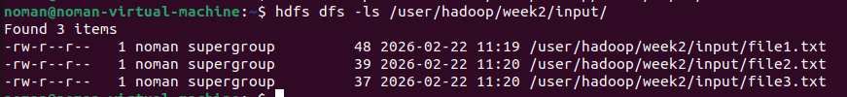

Command 5: View File Content
Read what's inside a file in HDFS:
hdfs dfs -cat /user/hadoop/week2/input/file1.txt
💡 Command Breakdown:
- -cat: 'Concatenate' - displays file contents on screen

✅ You should see:
Hadoop is a framework for distributed computing

Command 6: Check File Statistics
Get detailed information about a file:
hdfs dfs -stat "%b %r %n" /user/hadoop/week2/input/file1.txt
💡 Command Breakdown:
- -stat: Show file statistics
- %b: File size in bytes
- %r: Replication factor (how many copies of the file exist)
- %n: File name

✅ Expected Output:
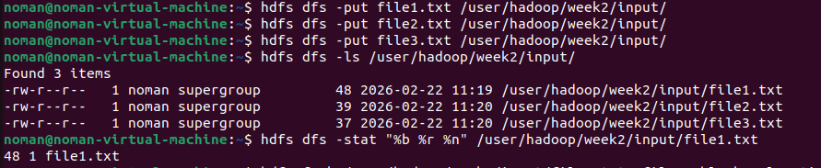
This means: File is 48 bytes, has 1 replicas, and is named file1.txt

Exercise 2: Understanding HDFS Blocks

Command 7: View Block Information
See how HDFS stores your file in blocks:
hdfs fsck /user/hadoop/week2/input/file1.txt -files -blocks -locations
💡 Command Breakdown:
- fsck: 'File System Check' - checks health and shows details of files
- -files: Show file names
- -blocks: Show which blocks make up the file
- -locations: Show which DataNodes (machines) store each block

✅ Expected Output: You'll see something like:
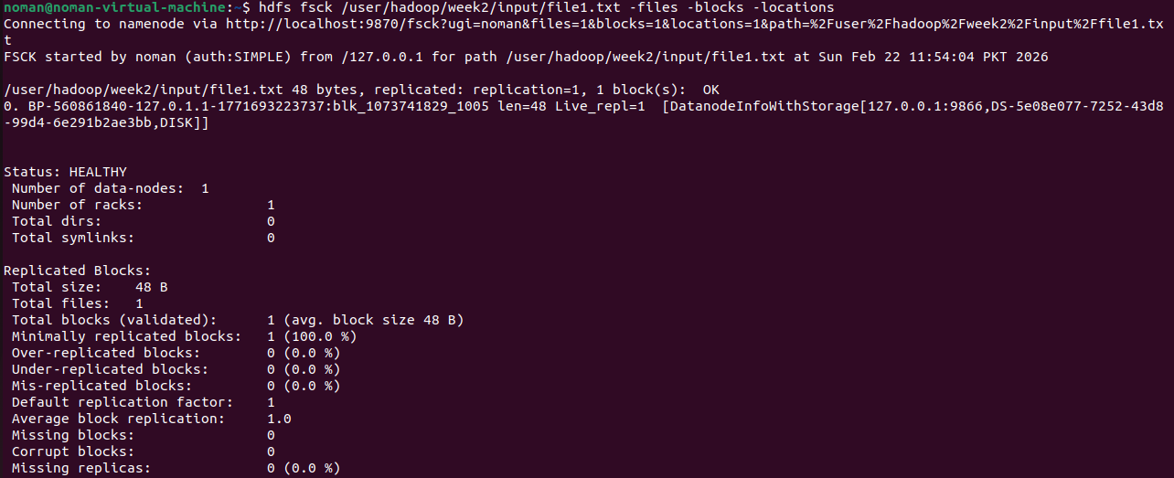
💡 What this tells you:
- Your file is stored as 1 block (because it's small - only 48 bytes)
- This block has 1 replica (copy)
- It shows which DataNode machines store these copies

Exercise 3: Change Replication Factor

Command 8: Modify Replication
Change how many copies of your file exist:
hdfs dfs -setrep -w 1 /user/hadoop/week2/input/file1.txt
💡 Command Breakdown:
- -setrep: 'Set replication' - change how many copies exist
- -w: 'Wait' - wait for the replication to complete before command finishes
- 1: New replication factor (change from 3 copies to 1 copies)

Verify the change:
hdfs dfs -stat "%r" /user/hadoop/week2/input/file1.txt
✅ Expected Output:
1
This confirms the file now has only 1 replicas instead of 3!

Exercise 4: Advanced MapReduce with Python
Now we'll create a more advanced MapReduce program that counts words AND tracks which line numbers they appear on!

Step 1: Create Advanced Mapper
Open nano text editor:
nano mapper_advanced.py
Type (or copy-paste) this Python code:
#!/usr/bin/env python3
import sys

line_num = 0

for line in sys.stdin:
line_num += 1
line = line.strip()
words = line.split()

for word in words:
word = word.lower()
print(f"{word}\t1\t{line_num}")
💡 Code Explanation:
- line_num = 0: Start counting from line 0
- for line in sys.stdin: Read each line from input
- line_num += 1: Increment line counter
- line.strip(): Remove extra spaces
- words = line.split(): Split line into individual words
- word.lower(): Convert to lowercase (so 'Hadoop' and 'hadoop' are same)
- print(f"{word}\t1\t{line_num}"): Output: word, count=1, line number (separated by tabs)

Save: Ctrl+O, Enter, then Exit: Ctrl+X

Step 2: Create Advanced Reducer
nano reducer_advanced.py
Type this code:
#!/usr/bin/env python3
import sys

current_word = None
current_count = 0
line_numbers = []

for line in sys.stdin:
parts = line.strip().split('\t')

word = parts[0]
count = int(parts[1])
line_num = parts[2]

if current_word == word:
current_count += count
line_numbers.append(line_num)
else:
if current_word:
print(f"{current_word}\t{current_count}\t{','.join(line_numbers)}")

current_word = word
current_count = count
line_numbers = [line_num]

# print last word
if current_word:
print(f"{current_word}\t{current_count}\t{','.join(line_numbers)}")
💡 Code Explanation:
- line_numbers = []: List to store all line numbers where word appears
- parts = line.strip().split('\t'): Split input into: word, count, line_num
- if current_word == word: If same word as before, add to count
- line_numbers.append(line_num): Record this line number
- ','.join(line_numbers): Combine all line numbers with commas (e.g., '1,2,5')

Save and exit.

Step 3: Make Scripts Executable
chmod +x mapper_advanced.py reducer_advanced.py
💡 What this does: Makes the Python files executable (runnable)

Step 4: Run the MapReduce Job
First, remove old output (if exists):
hdfs dfs -rm -r /user/hadoop/week2/output
💡 What this does: Deletes the output folder (Hadoop won't run if output folder already exists)
Now run the MapReduce job:
hadoop jar $HADOOP_HOME/share/hadoop/tools/lib/hadoop-streaming-*.jar \
-input /user/hadoop/week2/input \
-output /user/hadoop/week2/output \
-mapper mapper_advanced.py \
-reducer reducer_advanced.py \
-file mapper_advanced.py \
-file reducer_advanced.py
💡 Command Breakdown:
- hadoop jar: Run a Java jar file
- hadoop-streaming-*.jar: The Hadoop Streaming tool (lets us use Python instead of Java)
- -input: Where input files are in HDFS
- -output: Where to save results in HDFS
- -mapper: Which script to use as mapper
- -reducer: Which script to use as reducer
- -file: Copy these files to all nodes (so they can run)

⏳ This will take 30-60 seconds. You'll see lots of output showing progress.
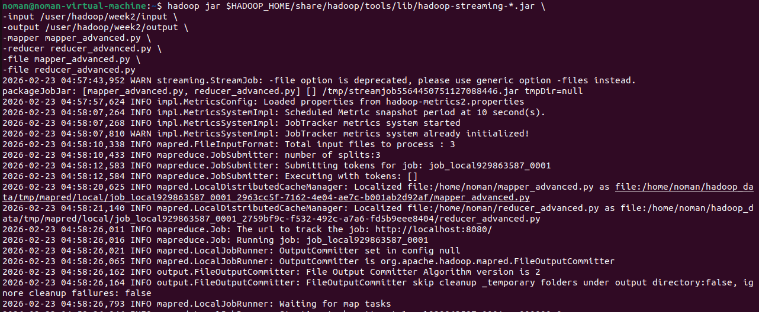

Step 5: View Results
hdfs dfs -cat /user/hadoop/week2/output/part-00000
✅ Expected Output: You'll see words with their counts and line numbers:
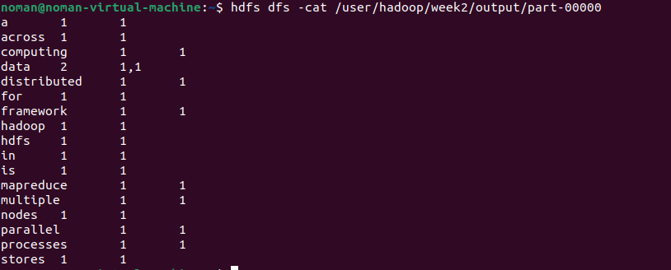
💡 Reading the results:
- 'a 1 1' means: word 'a' appears 1 time, on line 1
- 'across 1 1' means: word 'across' appears 1 time, on line 1
- 'computing 1 1' means: word 'computing' appears 1 time, on line 1
- 'data 2 1,1' means: word 'data' appears 2 times, both on line 1
- 'distributed 1 1' means: word 'distributed' appears 1 time, on line 1
- 'for 1 1' means: word 'for' appears 1 time, on line 1
- 'framework 1 1' means: word 'framework' appears 1 time, on line 1
- 'hadoop 1 1' means: word 'hadoop' appears 1 time, on line 1
- 'hdfs 1 1' means: word 'hdfs' appears 1 time, on line 1
- 'in 1 1' means: word 'in' appears 1 time, on line 1
- 'is 1 1' means: word 'is' appears 1 time, on line 1
- 'mapreduce 1 1' means: word 'mapreduce' appears 1 time, on line 1
- 'multiple 1 1' means: word 'multiple' appears 1 time, on line 1
- 'nodes 1 1' means: word 'nodes' appears 1 time, on line 1
- 'parallel 1 1' means: word 'parallel' appears 1 time, on line 1
- 'processes 1 1' means: word 'processes' appears 1 time, on line 1
- 'stores 1 1' means: word 'stores' appears 1 time, on line 1

Exercise 5: Monitor Jobs with YARN
YARN (Yet Another Resource Negotiator) provides a web interface to monitor your Hadoop jobs.

Step 1: Open YARN Web UI
Open your web browser (Firefox or Chrome) and go to:
http://localhost:8088
💡 This opens the YARN ResourceManager web interface

Step 2: Explore the Interface
What you can see:
- Applications Tab: Click this to see all MapReduce jobs you've run
- Application ID: Each job has a unique ID like 'application_1234567890123_0001'
- Status: Shows if job is RUNNING, FINISHED, or FAILED
- Progress: Shows % complete

Step 3: View Job Details
Click on an Application ID to see:
- Number of mappers and reducers used
- How long the job took
- Resource usage (memory, CPU)
- Job counters (how many records processed, bytes read/written)
- Logs (if something went wrong)

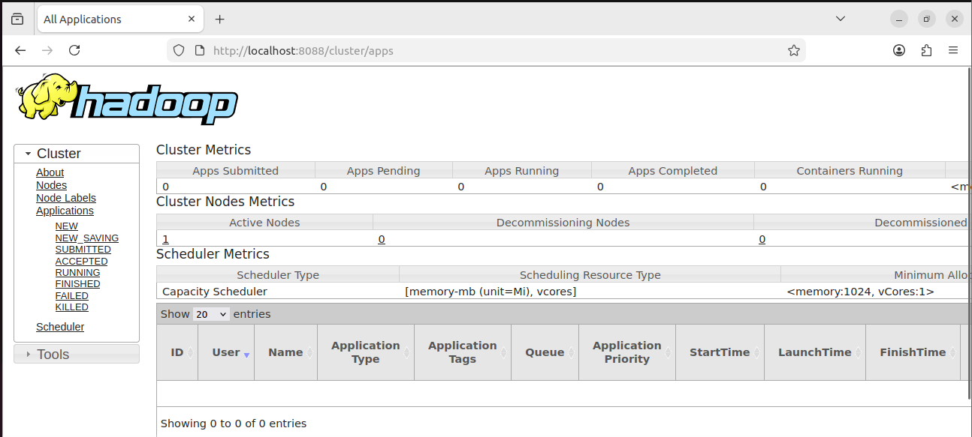
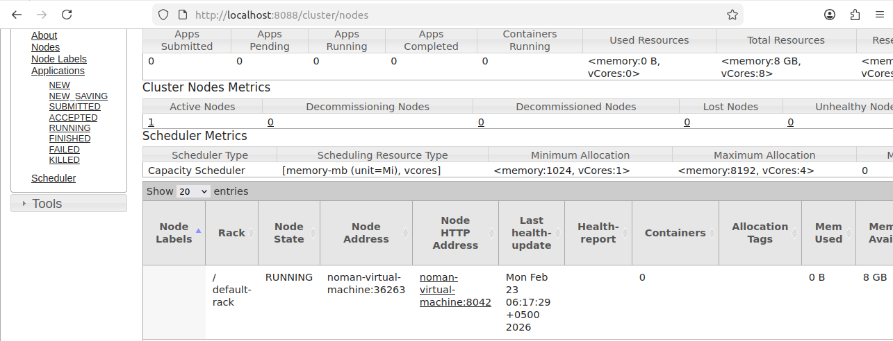
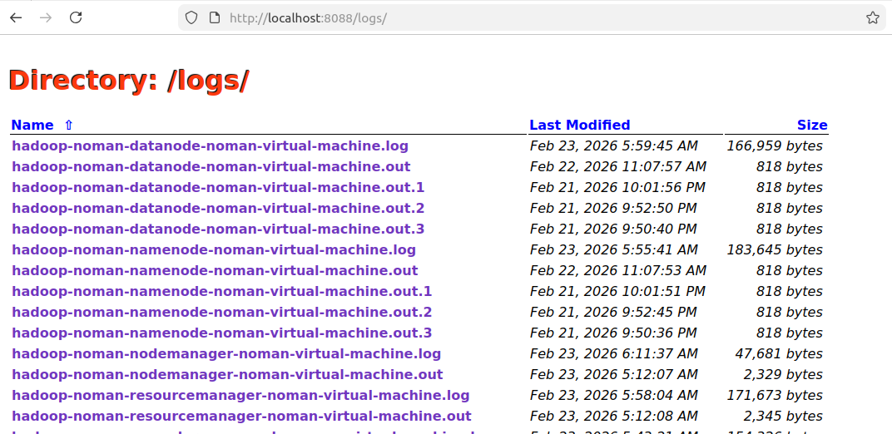

Discussion Questions
Answer these in your report:
- Explain the role of NameNode and DataNode in HDFS. What happens if NameNode fails?
- What is the default block size in HDFS? Why are blocks replicated?
- Describe the Map and Reduce phases in MapReduce with an example.
- What is the shuffle and sort phase? Why is it necessary?
- Explain the difference between YARN ResourceManager and NodeManager.
- What is data locality in Hadoop? Why is it important?
- How does HDFS handle file reads and writes? Explain the process.
- What is Secondary NameNode? Is it a backup of NameNode?

